**Beam Position Log for LZM-100.00330**

Rear Thermopile Serial #: 3066697

Front Thermopile Serial #: 3059279

**17 December 2022**

No lens. Max brightness. No offset. 600 bits.

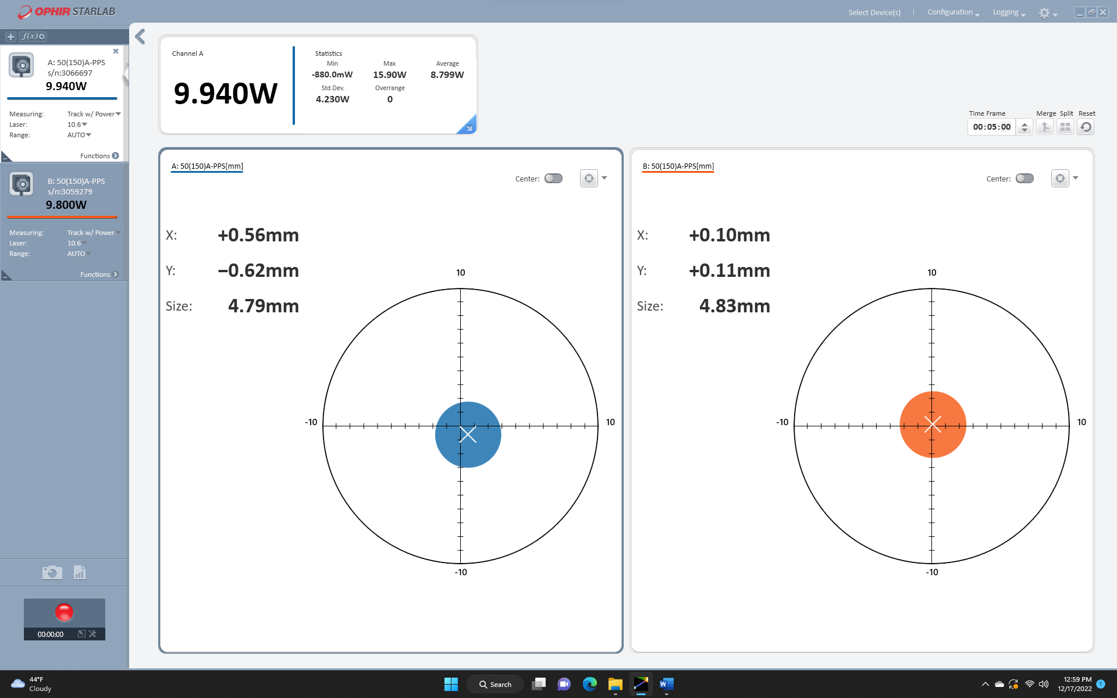

Power Calibration: 621, 620, 637, 620, 620, 622, 621, 632, 622, 619

19 December 2022

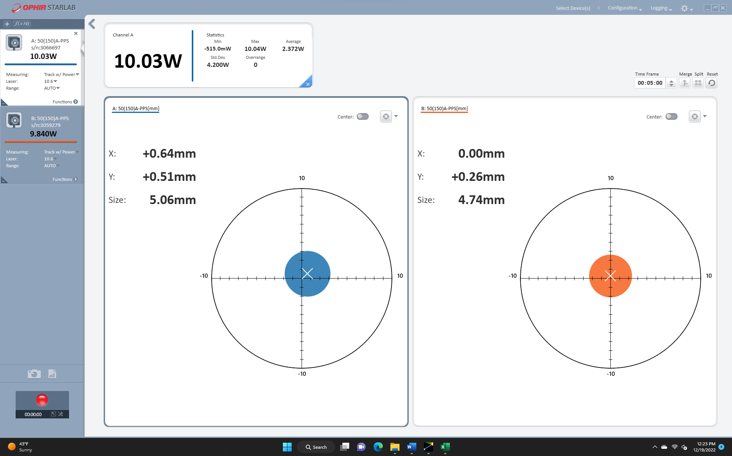

Power Calibration: 628

No lens. 1.5 mm offset. 600 bits

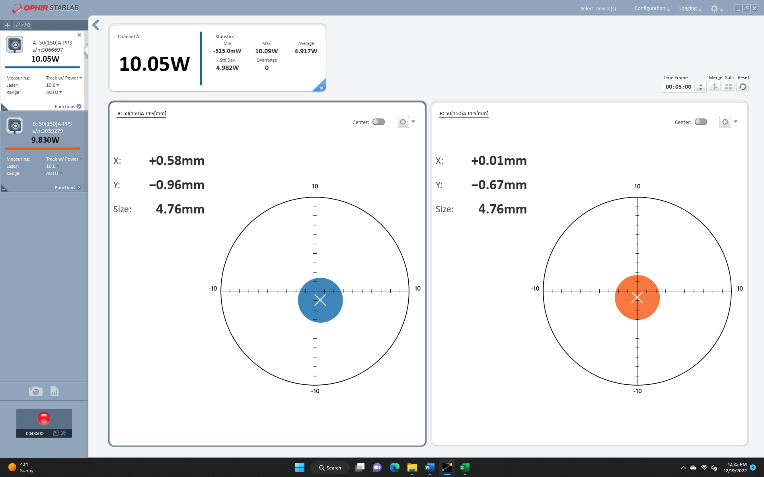

Power Calibration: 657

No lens. Max brightness. No offset. 600 bits.

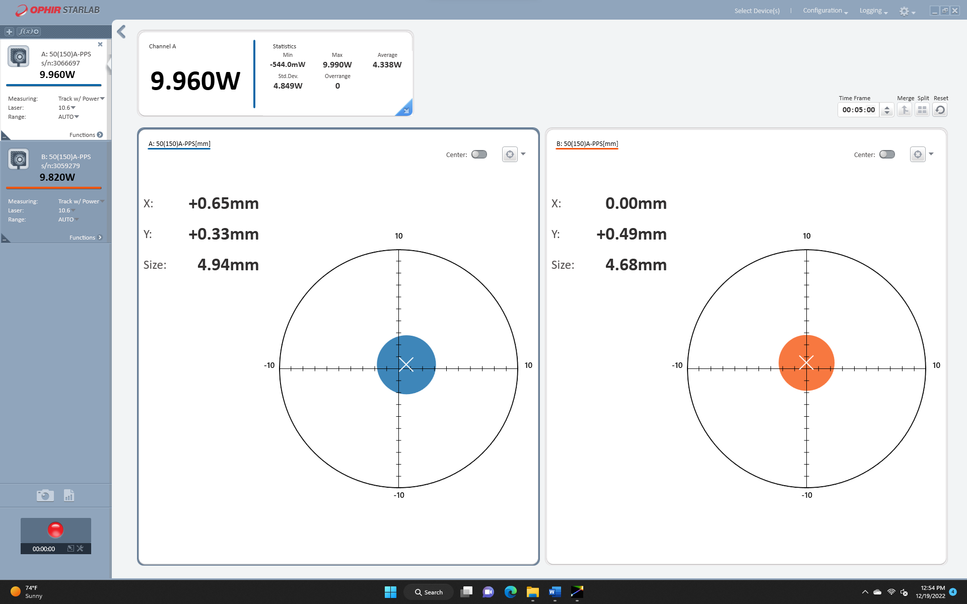

Power Calibration: 622

Cylindrical f10.5 lens. Max brightness. No offset. 300 bits.

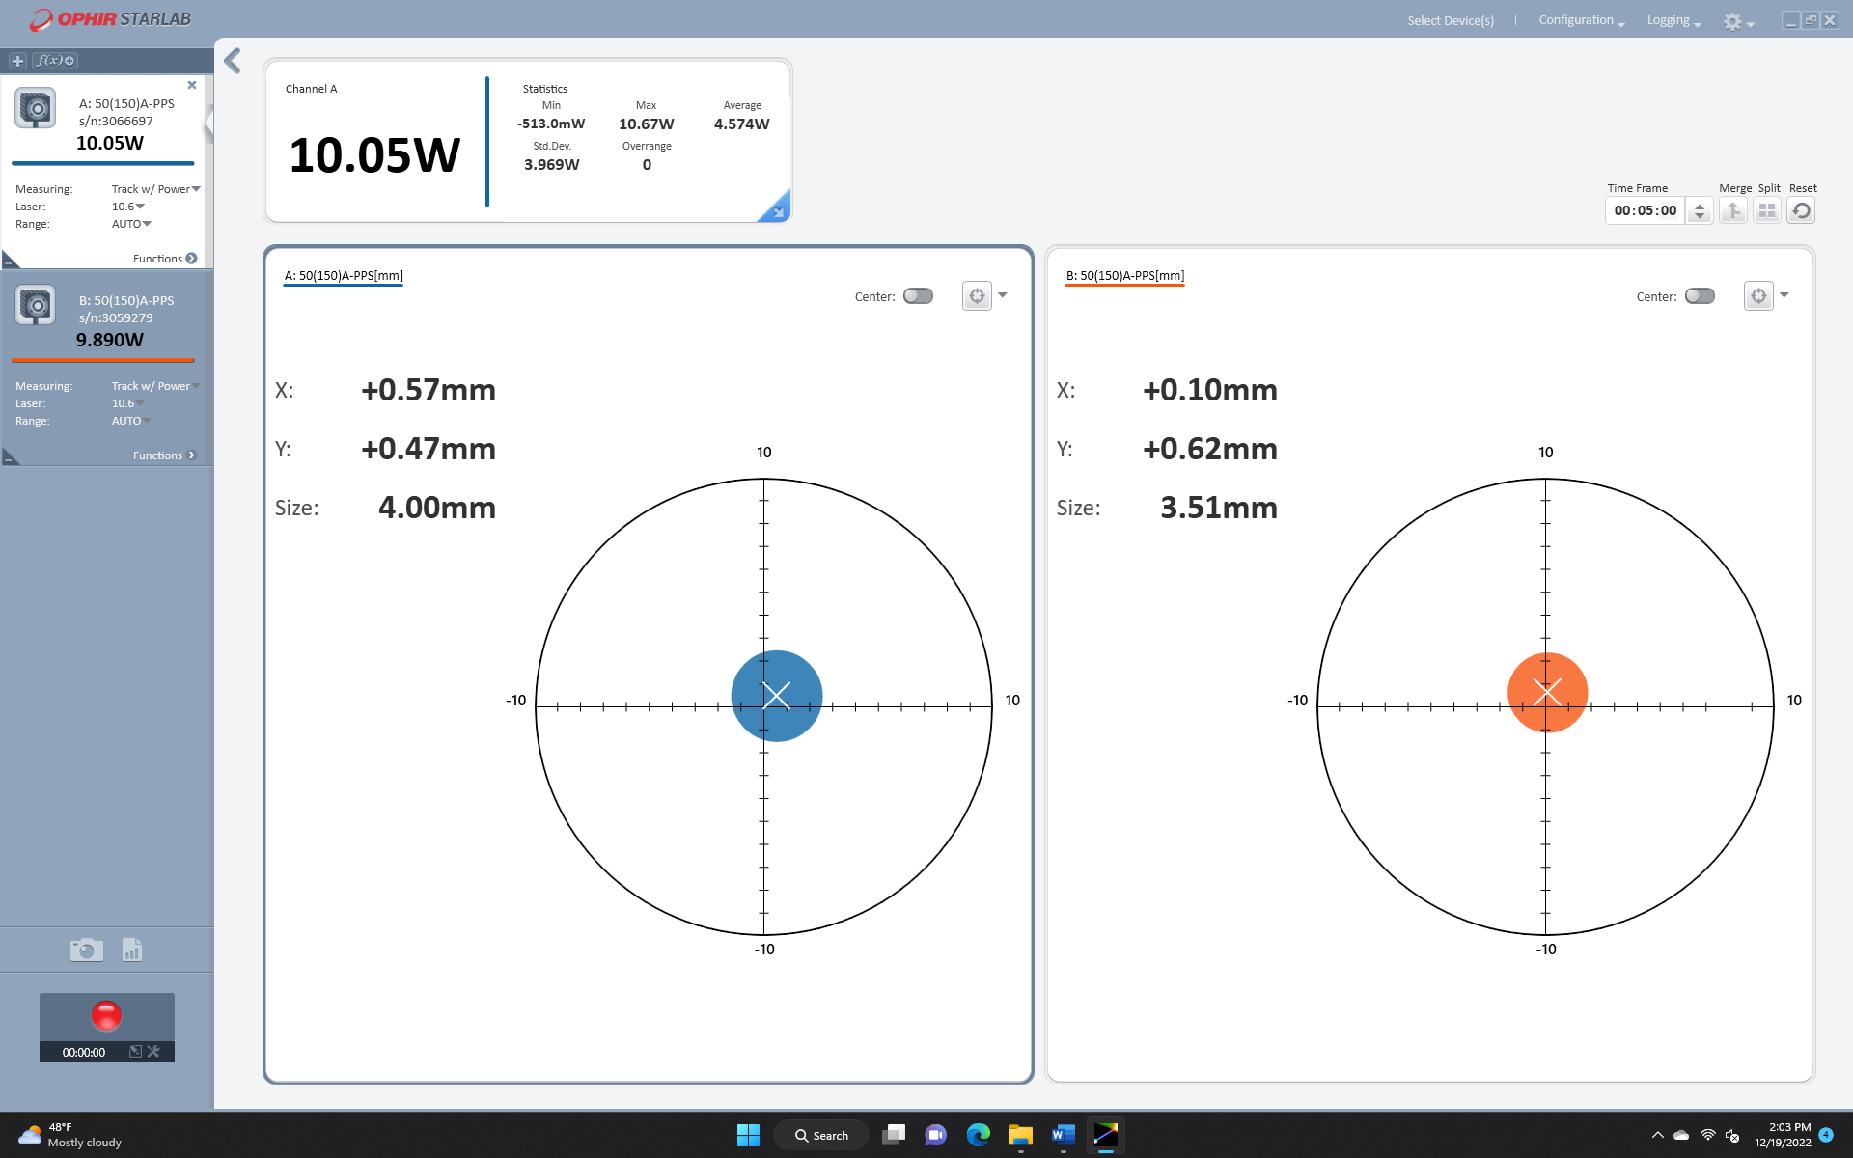

Power Calibration: 345

**19 December 2022**

**Final Beam Position:**

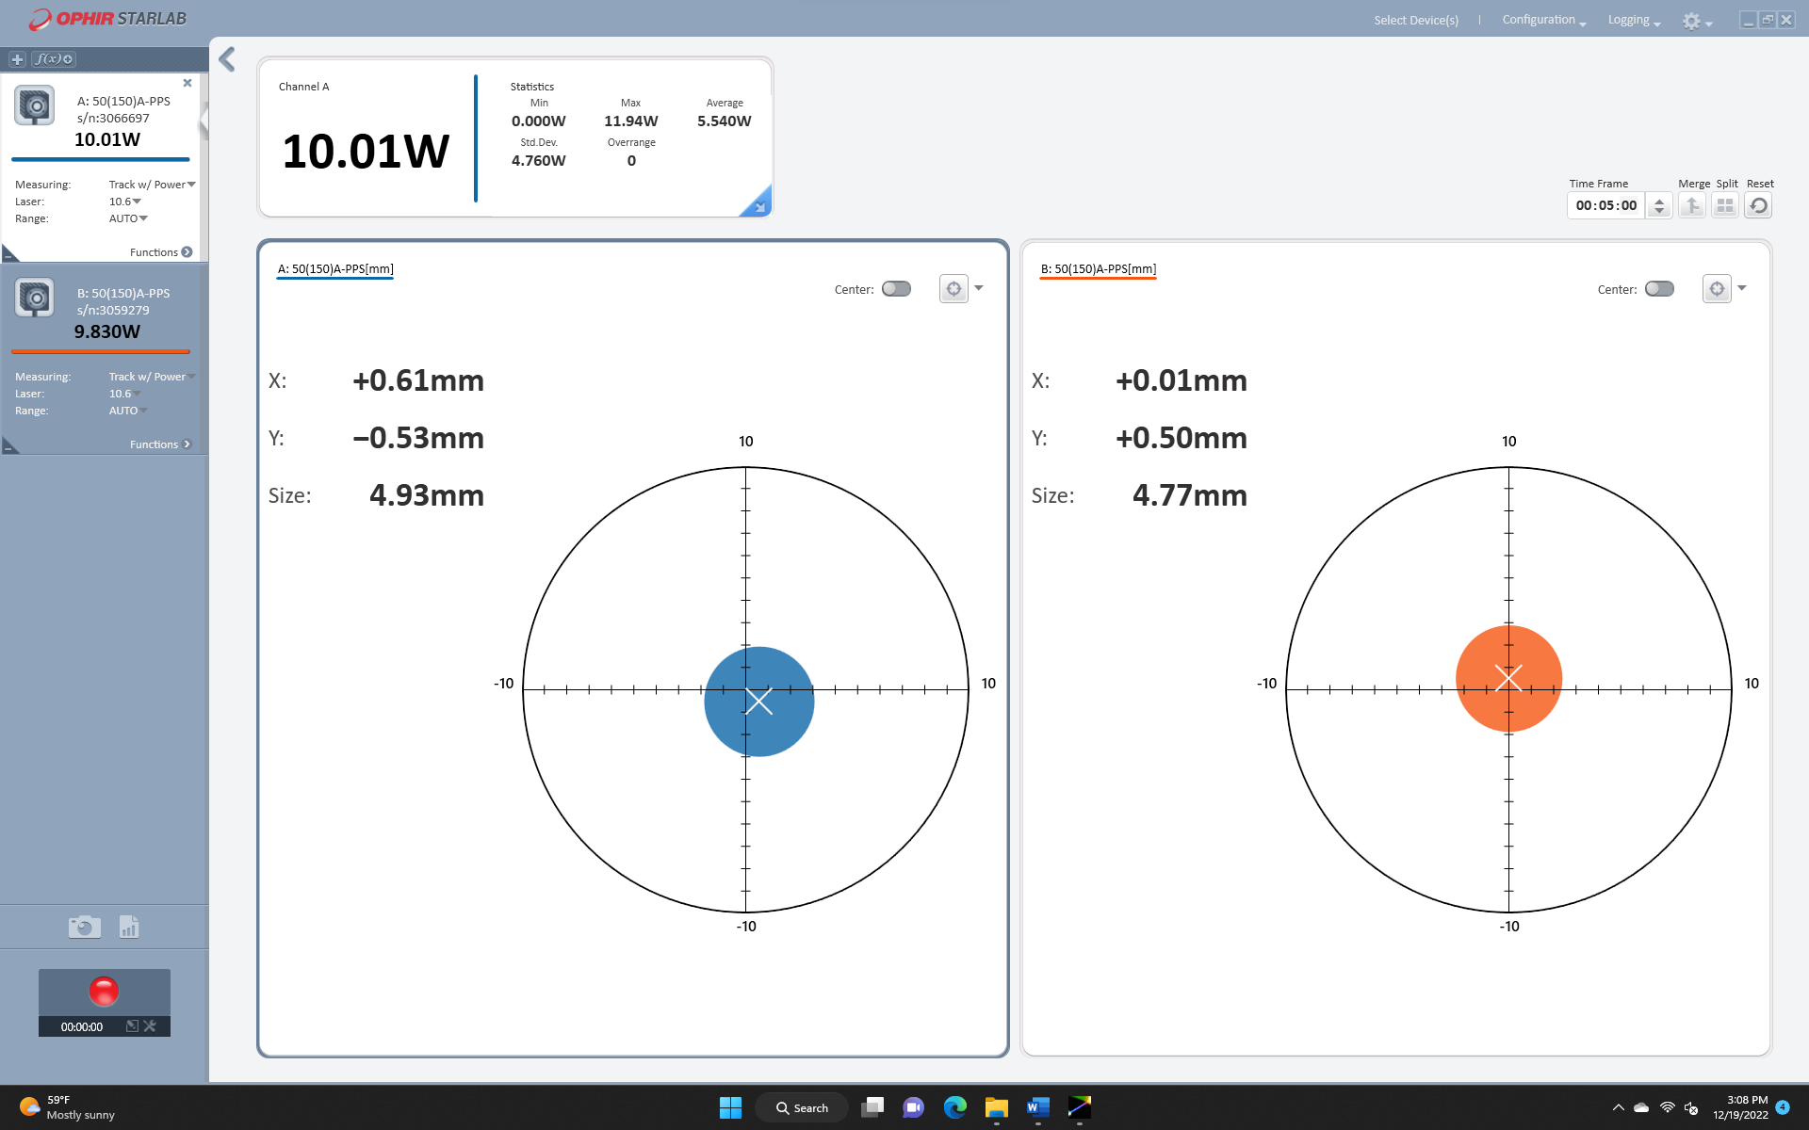

Power Calibration: 632

Max Brightness